Kyle

Schematic
- Need to change connector to analog controller
- 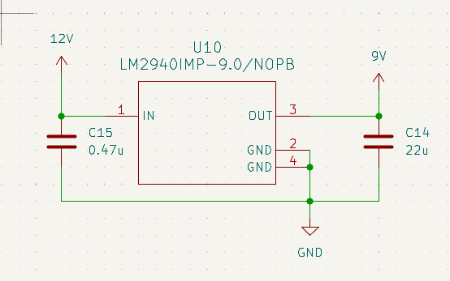 Can Big Muff run on 12 V? can save on component parts if we use 12 instead of 9
- 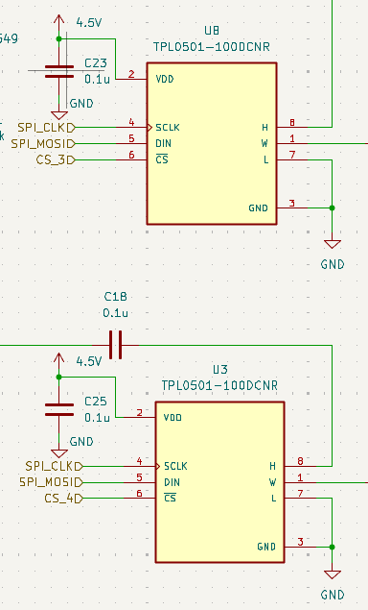 If these are to take more of one and less of another, we use just 1 CS and connect the analog signals opposite of each other. One is H->W->L and the other is L->W->H. When we send the same message, to both in this configuration, they will automatically be opposites of each other.
- 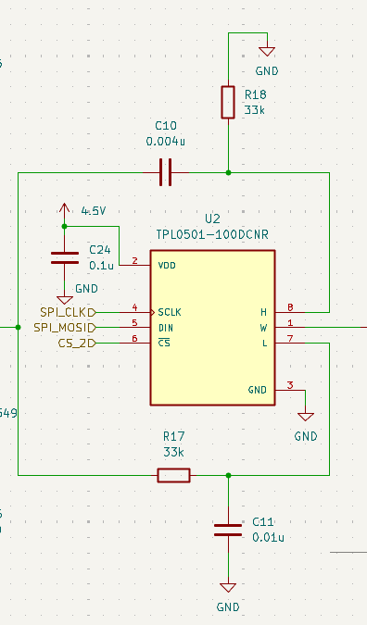 Is decoupling needed on the lower signal?

Layout
- 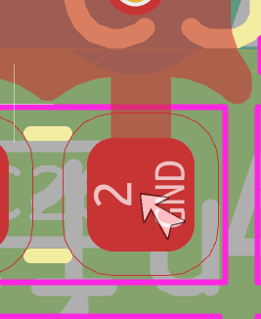 If we care about thermal relief
- 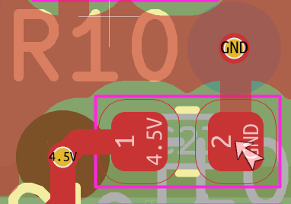 thermal relief
- 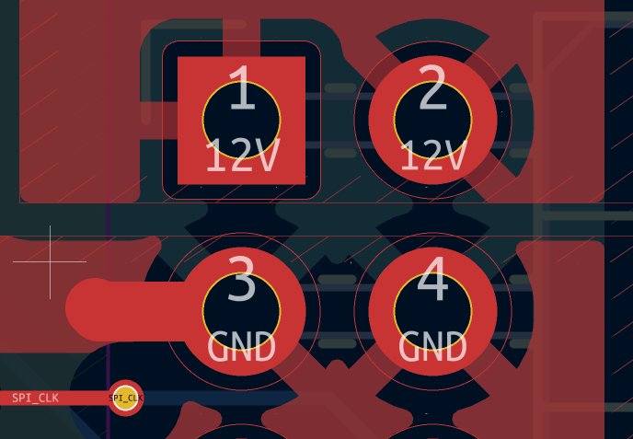track just chilling. Not connected to anything.

